Student: Glavin Wiechert
Group Member: Victoria Coe
Due Date: May 2, 2011
Teacher: Louth, Ellen Mary
Class: Chemistry 11 Ad

Introduction:
An empirical formula of a chemical compound is the ratio of atoms in simplest whole-number terms of each present element in the compound. For example, Glucose is C₆H₁₂O₆; it’s empirical formula is CH₂O.

A hydrate is a compound that is chemically combined with water molecules. In contrast, an anhydrate does not contain water, and has had all of its water removed.

Purpose:
The purpose of this experiment is to identify the unknown hydrate, selected by your teacher.

Apparatus:
Evaporating dish Hot plate Scale
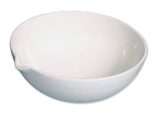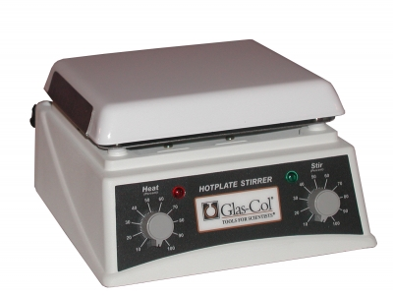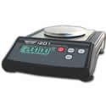

Gauze mat Tongs Scoopula
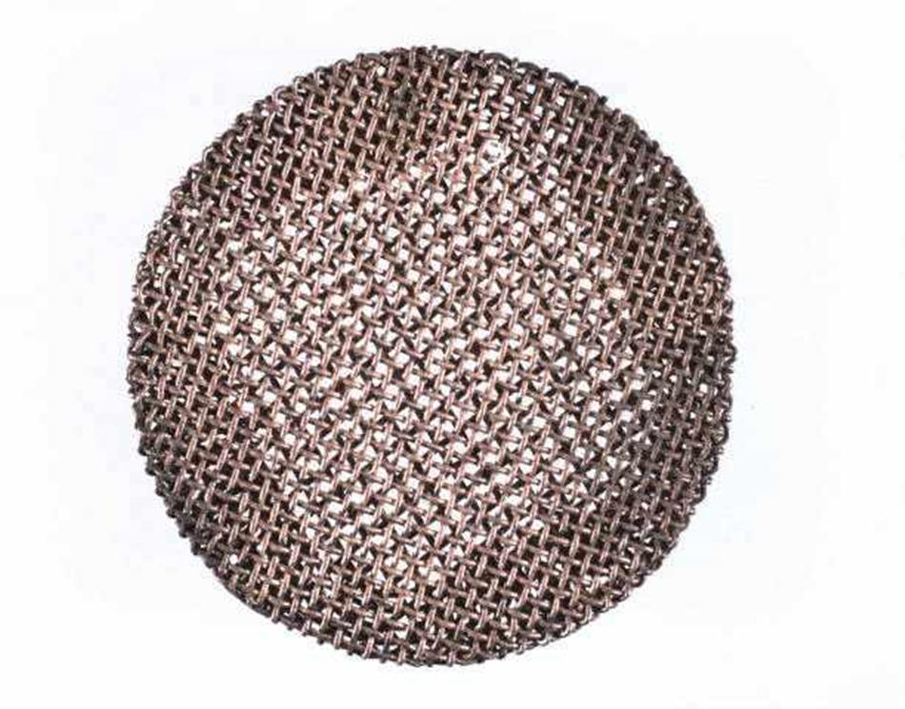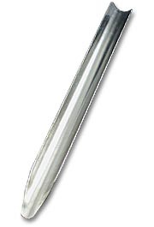

Materials:
barium chloride (BaCl₂) → hydrate crystals

Procedure:
- First, preheat your evaporating dish on a hot plate for two to three minutes. Your dish should be clean and dry before use.

- After your evaporating dish is heated, let it cool for at least three minutes. Use your tongs to move the dish to a suitable cool-down location.

- Once you dish has cooled down enough for touch put it on a scale.
  - Find the mass to the nearest 0.01g.

- Obtain about 2 grams of a sample hydrate (e.i. barium chloride). Make observations and then carefully transfer the crystals to your crucible or evaporating dish.

- Mass and record the dish with the hydrate crystals (BaCl₂) to the nearest 0.01g.

- Place the evaporating dish on the hot plate and heat gently until the water has been driven off (Heat until there is no more popping or spattering). Allow the dish to cool.

- When the dish is cool enough to touch, transfer it to a scale and find the mass.

- To make sure all the water is driven off, heat the dish another time (Repeat step 6 & 7).
  - (Step 7) Cool and find the mass. If the results do not agree within 0.02g, consider repeating the step.

Data & Observations:

Barium Chloride (BaCl₂) - Find Molar mass
Cl 2 x 35.45 g/mol ⇒ 70.90 g/mol → Molar Mass of the 2 Cl

137.32 g/mol → Molar Mass of Ba
+ 70.90 g/mol → Molar Mass of 2 Cl
208.22 g/mol ⇒ Molar Mass of BaCl₂

- Mass of Crucible: 35.82 g

- Mass of Hydrate (BaCl₂): 1.98 g

Mass of crucible & hydrate: 37.77 g (~37.80)

- Mass of crucible and anhydrous salt after first heating: 37.47 g

- Mass of crucible & anhydrous salt after second heating: 37.47 g

- Formula mass of 1 mole of anhydrous salt:
37.47 g
- 35.82 g
1.65 g ⇒ Mass of anhydrous salt
37.77 g
- 37.47 g
0.30 g ⇒ Mass of Water
1.65 x [1 mol / 208.22 g] = 0.0079 mol → moles anhydrous salt
0.30 x [1 mol / 18.02 g] = 0.0167 mol → moles of water
Ratio of water to anhydrous salt:
0.0167 mol / 0.0079 mol
⇒ 2.1139 (~2)
Formula mass of 1 mole of anhydrous salt: BaCl₂ • 2H₂O

Data Analysis:
Calculations & results:
- 37.77 g → Mass of crucible & hydrate
35.82 g → Mass of Crucible
1.95 g → Mass of Hydrate (BaCl₂)

- 37.77 g
- 37.47 g
0.30 g ⇒ Mass of Water Lost

- 0.30 x [1 mol / 18.02 g] = 0.0167 mol → moles of water (H₂O)

- 37.47 g
- 35.82 g
1.65 g ⇒ Mass of anhydrous salt

- 1.65 x [1 mol / 208.22 g] = 0.0079 mol → moles anhydrous salt

- Ratio of water to anhydrous salt:
0.0167 mol / 0.0079 mol → moles of water lost / moles of anhydrous salt
⇒ 2.1139 (~2) → ratio of the salt to water

- Barium Chloride Dihydrate: BaCl₂ • 2H₂O

- %Water (H₂O)
0.30 g / 1.95 g
⇒ 0.1538 ⇒ 15.4%

%Salt (BaCl₂)
1.65 g / 1.95 g
⇒ 0.8461 ⇒ 84.6%

Questions:
- A hydrate is a compound that is chemically combined with water molecules. Contrasting to a hydrate an anhydrate does not contain water, and has had all of its water removed.

- Einstein told us that all mater is a form of energy, and thus the hotter and more energy an object has, the more mass. However, for our experiment and using our instruments, there is negligible effect regarding temperature in that respect. Something that we can consider though, is convection currents of hot objects. The mass is stable, however, the apparent mass, which is measured by the scale, changes periodically when hot, because the convection currents apply forces on the scale that are sometimes enough to make an accurate scale inaccurate. When cooled, the object’s mass can be easily and precisely read.

  - If the hydrate was not heated long enough to extract all of the water then the mass of water lost would be incorrect. If the mass of water lost is wrong, then the water lost in moles will most likely also be incorrect. Then, finally, when getting the ratio of water to salt, since the water lost in moles is wrong, the ratio will be off and inaccurate. Given the incorrect ratio, the empirical formula will also be wrong to a degree. The data collected was wrong, so the result was correspondingly wrong.

  - The dampness (water) on the crucible will be accounted for in the initial masses, and then be evaporated later when heated. The masses will be offset by that mass of the unseen water on the crucible. The mass of the crucible itself will be greater and, after that water has been evaporated with the water in the hydrate, the mass of the water lost will be greater than it should be. See above for ramifications of inaccurate water measurements.

  - There are water molecules in the air, and at night the air can be moist. Given time, there is a good chance the anhydrous salt will absorb water and become a hydrate again. This would defeat the purpose of heating the hydrate in the first place.

  - If a chemical change occurs by applying intense heat, the resulting elements would react differently than the combined product for which the experiment was designed.

Conclusion:
This experiment was completed successfully. All required masses were found and the process was followed presicsely. The unknown hydrate was identified as Barium Chloride Dihydrate, BaCl₂ • 2H₂O.

